Burundi

Burundi is a small land-locked country situated between 2.3°S to 4.5°S of latitude and 28.8°E to 31°E of longitude. It is bordered by Tanzania in the east and south, Rwanda in the north, Democratic republic of Congo (DRC) in the west. The total area of the country is 27,834 sq. km and population is about six million. Physical features in Burundi

The main physical features of the country include a variety of ecological regions. These include IMBO region, which comprises lowlands in the western parts of the country, CONGO/NILE CREST region comprising of high mountain ranges, KIRIMIRO region made of central plateaus, KUMOSO region comprising of low-lying terrain in eastern areas, the BWERU region made up of plains in the north and BUGESERA region constituting lowlands in the northeastern parts of the country. Generally, Burundi lies in high altitudes that range from 774m to 2670m above sea level.

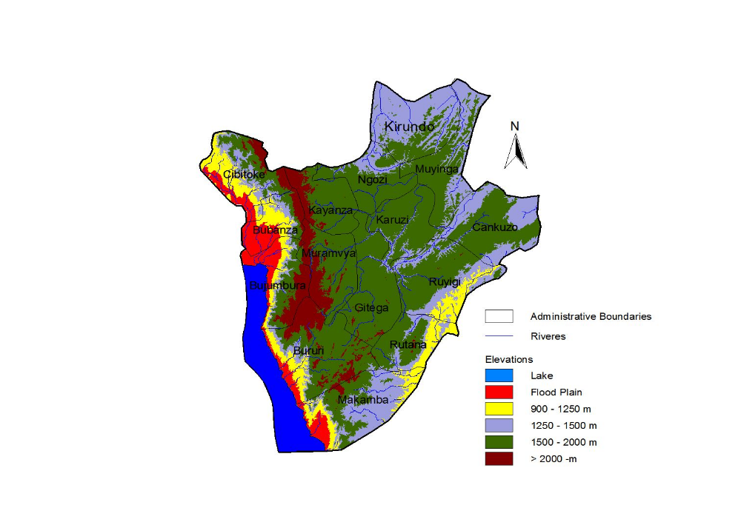

Figure 1 Main Physical features and flood risk map of Burundi

Climatology of Burundi
Burundi has a “moderate” tropical climate with average temperatures between 16 ºC and 25 ºC. In the west parts of the country where it is hotter, average temperatures are about 25ºC. The country has two major seasons: the dry season from June to September and the rainy season from September to May. The rainy season is made up with two parts, a short rain season from September to December. Between January and February there is a short dry season with frequent dry spells. From mid-February to May there is a long rain season. The distribution of the rains during the rainy seasons is irregular with the highest amounts in the northwest. Dry seasons vary in length, and there are sometimes long periods of drought. However, four seasons can be distinguished: the long dry season (June–August), the short wet season (September–December), the short dry season (mid January-mid February), and the long wet season (February–May). Most of Burundi receives between 1300 and 1600 mm of rainfall a year. The Ruzizi Plain in the West and the northeast receive between 700 and 1000 mm. In some areas, the amount of rainfall received during the short rains is more than that received in the long rains season. The rainy seasons are separated by dry periods in January and June to mid September. The vegetation is lush and agriculture important.

The seasonal rainfall patterns exhibit highly bimodal regimes (Figure 2). The rainfall peaks are generally concentrated in the months of March-May and October-November. The two rainy seasons are referred to as the long and short rainfall seasons. In some cases, however, the short rainfall season in more significant.

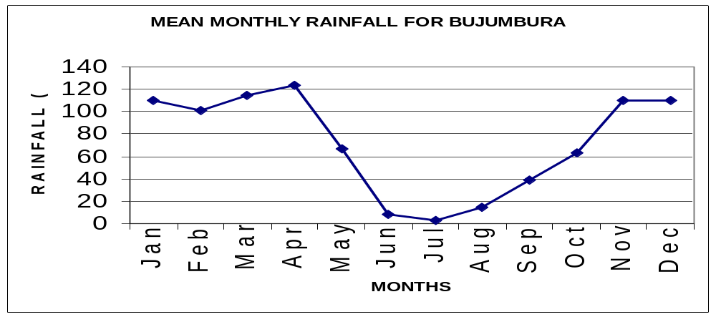
(a) Bujumbura
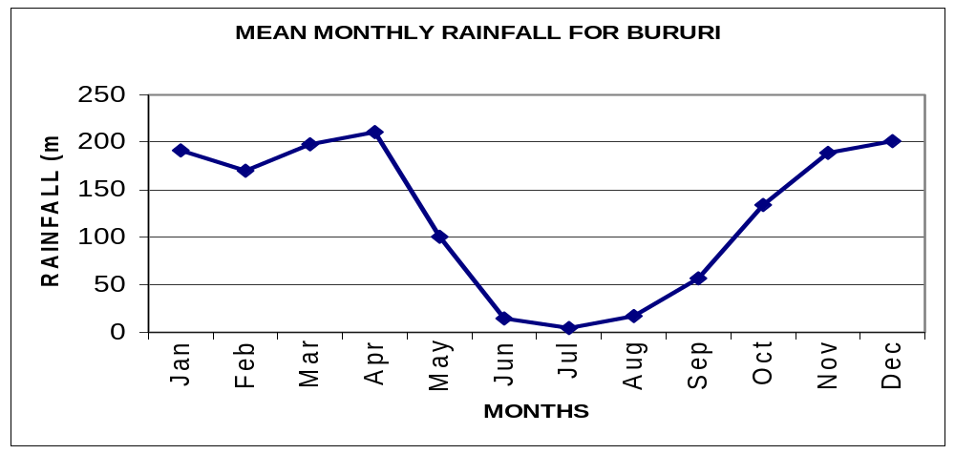
(b) Bururi
Figure 2: Mean monthly rainfall or annual cycle for Burundi

Factors affecting climate in Burundi

The climate in Burundi is mainly influenced by the North-South movement of the ITCZ, the topography of the country and the El-Nino southern oscillation (ENSO). The rainfall depicts very strong seasonality in harmony with the meridional migration of the Inter-Tropical Convergence Zone (ITCZ), which is the main weather system generating rainfall over the country. The Congo airmass is another system, which has influence on rainfall over the country through the advection of its moist air. The seasonal rainfall patterns exhibit highly bimodal regimes. The rainfall peaks are generally concentrated in the months of March-May and October-November. The two rainy seasons are referred to as the long and short rainfall seasons. In some cases, however, short rainfall season in more significant. Figure 3 gives the climatological zones of Burundi. The major weather systems influencing rainfall over the country can be summarized as Intertropical Convergence Zone (ITCZ), The Congo Airmass, Equatorial Trough, East African Ridge, the Southern Hemisphere semi-permanent Sub-Tropical High Pressure Systems namely the Mascarene and St. Helena anticyclones, plus other Ocean-atmosphere phenomena such as ENSO events.

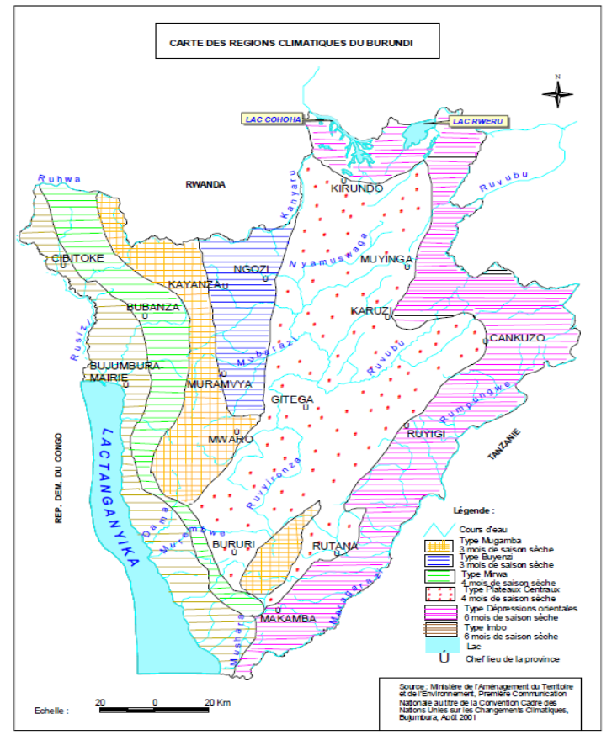
Figure 3 Burundi Climatological zones (Source, NAPA 2007)

Annual Rainfall Distribution

High annual and seasonal rainfall occurs over the Congo/Nile crest highlands while the western lowlands experience low rainfall. The mean annual rainfall over Burundi ranges from 1940mm in the Congo/Nile crest highlands to 864mm in the western lowlands.

The mean MAM seasonal rainfall ranges from 700mm to 305mm while the SOND seasonal rainfall ranges from 747mm to 323mm. The June – August season is generally dry and the country gets less than 50mm.

The DJF seasonal rainfall ranges from 614mm to 320mm with lower rainfall in the western and northeastern areas of the country. The spatial patterns of annual rainfall and for different seasons are shown in Figure 4a – e.

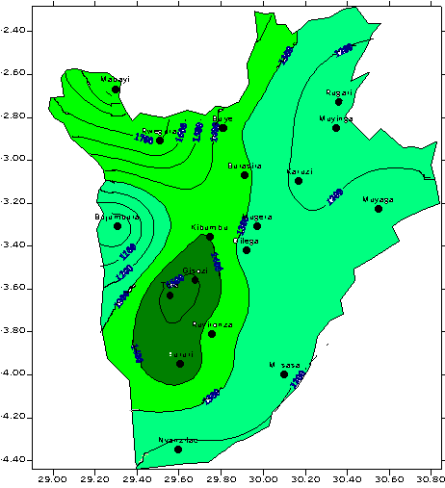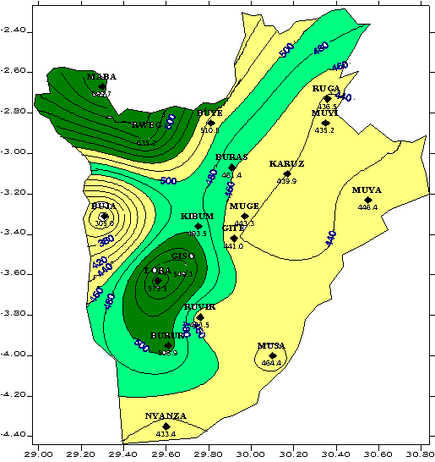

(a) Mean annual rainfall (b) March-May (MAM) rainfall
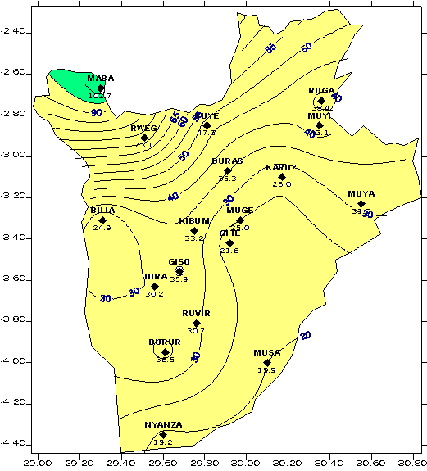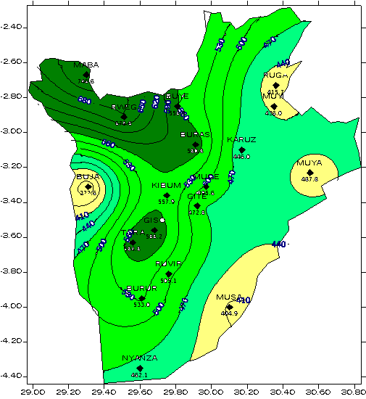

(c) June-August (JJA) rainfall (d) September-December (SOND) rainfall

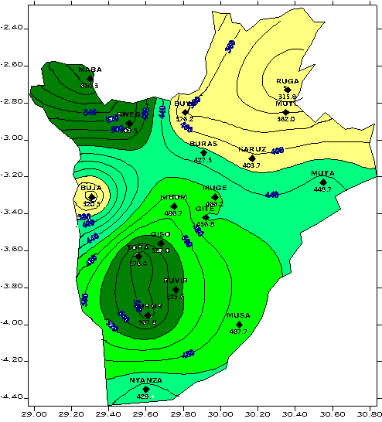
(e) December-February (DJF) rainfall

Figure 4 Spatial distribution of rainfall over Burundi

Climate variability and trends in Burundi

The First National Communication to the UNFCC and the NAPA reports on the cyclical nature of rainfall in Burundi. Analysis of the long term time series of annual precipitations in Burundi reveals a cyclic character, at intervals of more or less than 10 years, with alternating periods of surplus followed by rainfall deficit compared with the normal (Figure 5). Analysis of the change of the average temperature shows a persistent rise of temperature compared to the normal. The average temperature in the region has increased from 0.7 to 0.9°C since the years 1930 (NAPA, 2007).
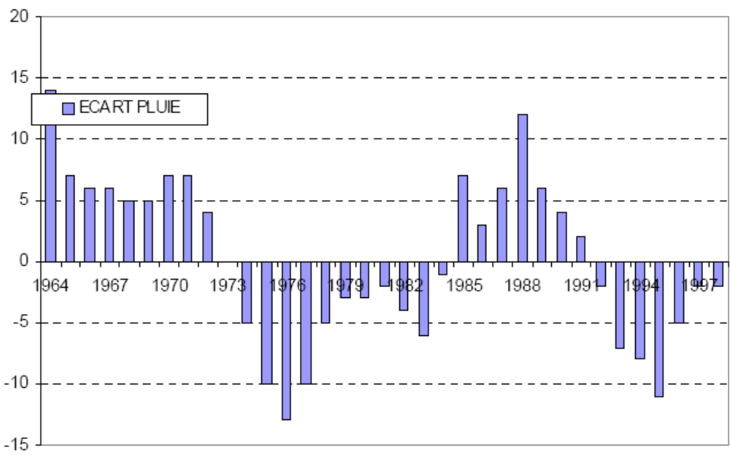
Figure 5 Percentage deviation from the mean precipitation for Gizosi, 1961-99. Source Minatte, 2001
Burundi has gone through many periods of climate related famine that are still engraved in the memory of Burundians (UNDP, 2005).

These include in particular the famines of the years 1917, 1923, 1931, 1933, 1943 and 1958 nationwide, and 1989-1990 in the regions of Bujumbura Rural, Bururi, Gitega and Muramvya, and 2000 – 2005 in the North-East of the country. Some of these famines are a result of climate changes (dryness, excess of rains, hail), whereas others result from invasions of predator insects, including migrating grasshoppers and locusts.
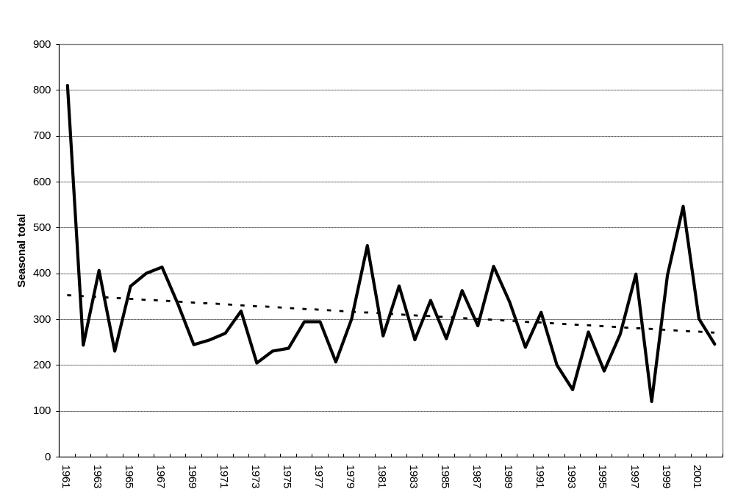
Figure 6 Trends of the March-May Seasonal rainfall over Bujumbura

Climatalogical disasters have been recorded (NAPA, 2006) as follows:
- The dryness of the years 1905-1909, 1921-1923, 1925-1928 (40,000 deaths), 1941-1944, 1950, 1974, 1984 and 1999-2000 in the North-East of the country;
- The hail that caused losses in food crops especially in the central plateaus, Muramvya (Mbuye) and Kayanza in 1990, Ngozi (Gashikanwa) and Bujumbura (Kanyosha) in 1989, and in Gitega (Nyamugari and Magarama) in 1991;
- The torrential rains in 1937, 1941, 1950, 1960, 1961 - 1964, 1983, 1986, 1989 and 1991 and especially floods in the city of Bujumbura, particularly in the Asian District in 1964, and Bubanza in 1989, 1997, 1998 and today, which caused regular cuts of roads combined with landslides and enormous damage on the infrastructures and the population. The most important damage was caused by the rise of the level of Lake Tanganyika between 1961 and 1964; its level increased by 4 m and the highest coast arrived at 777.6 m in May-June 1964. The districts of Bujumbura neighbouring the lake and the village of Gatumba were all flooded, whereas the roads Bujumbura-Uvira and Bujumbura- Rumonge were cut in several places.
- A food crisis in 2004 and 2005 was compounded by floods that occurred during the vegetative period for crops and a few days before bean harvests nationwide.
- In the region of Bugesera, since 1999, there is strong disturbance of the climate mode that results into very late beginning of precipitations resulting in the loss of harvests, famine, loss of human lives, displacement of population, etc. All the Northern lakes saw their level decreased with a water regression of more than 400m.
- Violent winds in Bujumbura in 1982 that caused destruction of a part of Bujumbura International Airport and accident of a small plane.
- Since the years 1999 to 2006, the annual evolution shows a shortening of the rainy season in the North-Eastern regions of the country, but with punctually violent rains coupled with thunders and lightning, and an extension of the dry season.
- since 1999, there has been increased variability of rainfall resulting in a long dry season from May to October (6 months) in the lower altitude outlying areas (Kumoso, Bugesera, Imbo).
- In the communes of Bugesera (Busoni, Bugabira in Kirundo Province and Giteranyi in Muyinga Province), there is a drying trend which is causing desertification.

To give an overview of numbers affected in the whole country by droughts and floods see Table 1.
Table 1 Number of people affected by drought, floods and storms in Burundi to September 2009. Source: EM-DAT: The OFDA/CRED International Disaster Database – www.emdat.net – Université catholique de Louvain – Brussels – Belgium

 | Drought | Flood | Storm | Total
1978 | 0 | 0 | 0 | 1530
1989 | 0 | 3600 | 0 | 3600
1992 | 0 | 0 | 0 | 2068
1997 | 0 | 0 | 0 | 24350
1999 | 650000 | 0 | 30810 | 1297244
2000 | 0 | 0 | 0 | 730591
2002 | 0 | 8000 | 0 | 10163
2003 | 0 | 0 | 0 | 230
2004 | 0 | 0 | 0 | 0
2005 | 2150000 | 0 | 0 | 2150000
2006 | 0 | 7000 | 0 | 7000
2007 | 0 | 2695 | 0 | 2695
2008 | 82500 | 3270 | 0 | 85770
2009 | 0 | 8000 | 0 | 8000
Total | 2882500 | 32565 | 30810 | 4323241

Climate projections for Burundi using SCENGEN
The MAGICC/SCENGEN model was used to investigate scenario changes in Burundi’s First National Communication (2001). The following section is translated from the First National Communication.
The selection of emission scenarios and parameters for the MAGICC model at the global level was the IS92A scenario as a reference, and for the projected policy scenario for climate changes was IS92C.
The selection of the model for the general circulation of greenhouse gases, was based on the resolution of the model and it sensitivity. Thus, the model HadCM2, which has a resolution of 2,5° latitude by 3,75° longitude, was chosen for Burundi. However, given that the resolution of the model is too big in relation to the size of Burundi, the data was interpolated use SCENGEN to produce a table of the changes in temperature and precipitation in relation to the baseline.
The tables 2a) and b) show that with climate change, average precipitation will increase slightly from 3% to 10 %. However, certain months, such as November, December, January, February and March will experience more rainfall (>25% in relation to the baseline situation). On the other hand, between May and October, the sites will see rainfall diminish from 4 to 16%.
With regards to the air temperature, between 2000-2050, a steady increase in average temperature of around 0,4 °C every 10 years is projected. The increase of air temperature by 2050 will reach 2.3°C and warming will be more significant during the long dry season (May to October).

Table 2a) Precipitation (change in %), high scenario
Year | Jan. | Feb. | Mar | Apr. | May | June | July. | Aug. | Sept. | Oct. | Nov. | Dec | Ann.
2010 | 11.6 | 7.2 | 6.3 | 3.6 | 3.5 | -4 | -4 | -4.2 | -5.5 | -1.2 | 6.5 | 9.5 | 2.9
2020 | 16.8 | 11.2 | 8.7 | 5 | 5.9 | -7.2 | -5 | -5.5 | -6.2 | -0.6 | 11.1 | 13.5 | 4.6
2030 | 23.5 | 15.6 | 13.3 | 6.5 | 8.2 | -10.3 | -7.3 | -5.9 | -7.6 | 0.1 | 16.4 | 17.9 | 6.6
2040 | 30.1 | 20.2 | 17.3 | 8.1 | 10.4 | -13 | -9.2 | -6.5 | -9.5 | 0.1 | 21.5 | 23.6 | 8.5
2050 | 36.9 | 24.7 | 21.3 | 9.5 | 12.2 | -16.5 | -11.4 | -8.4 | -11 | 0.2 | 26.1 | 27.6 | 10.3
Source : IGEBU, 2001.

b) Temperatures (change in °C), high scenario
Year | Jan. | Feb. | Mar. | Apr. | May | Jun | July | Aug | Sept. | Oct. | Nov. | Dec | Ann.
2010 | 0.6 | 0.6 | 0.8 | 0.8 | 0.9 | 0.9 | 1 | 1 | 1 | 1 | 0.9 | 0.7 | 0.8
2020 | 0.9 | 0.8 | 1.1 | 1.1 | 1.3 | 1.4 | 1.4 | 1.4 | 1.3 | 1.3 | 1.3 | 0.9 | 1.1
2030 | 1.1 | 1 | 1.5 | 1.4 | 1.7 | 1.6 | 1.9 | 1.9 | 1.9 | 1.7 | 1.7 | 1.2 | 1.5
2040 | 1.4 | 1.3 | 1.9 | 1.8 | 2.2 | 2.1 | 2.4 | 2.4 | 2.4 | 2.1 | 2.1 | 1.5 | 1.9
2050 | 1.7 | 1.5 | 2.3 | 2.1 | 2.7 | 2.5 | 2.9 | 2.9 | 2.9 | 2.5 | 2.6 | 1.9 | 2.3
Source IGEBU, 2001.

Figure 7 Historic temperature times series followed by SCENGEN projections up to 2050 for the stations of Gisozi and Mparambo.
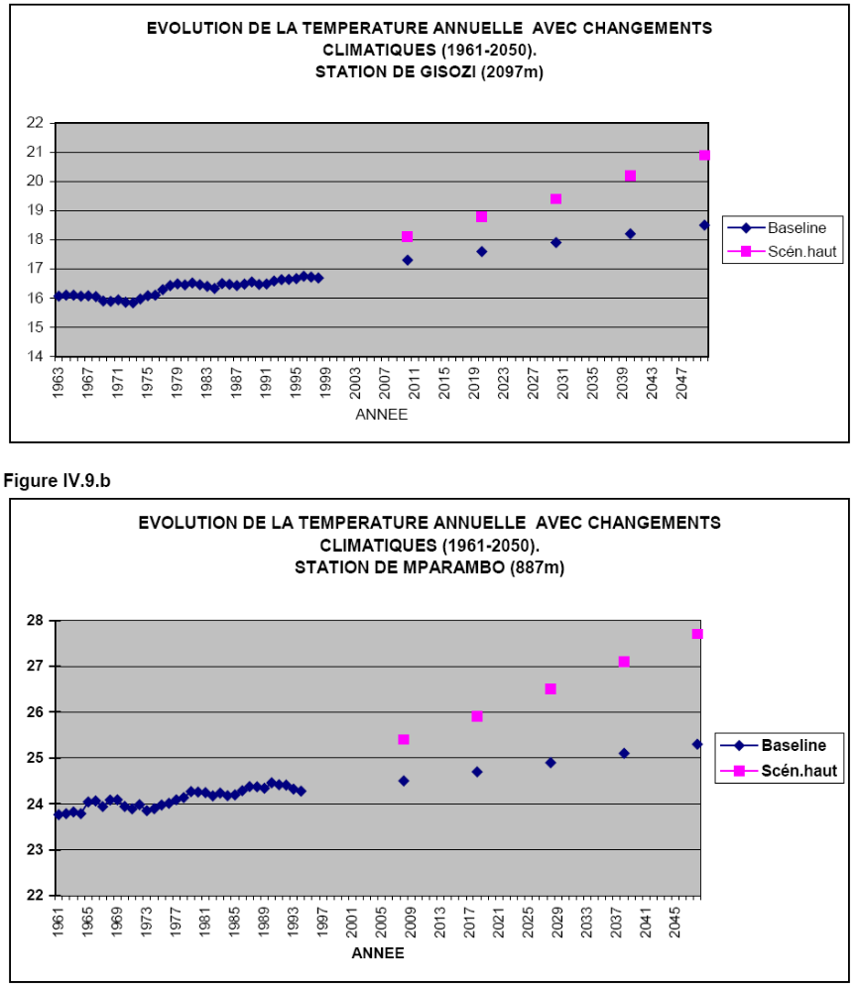
The 10 year cyclical nature of rainfall is expected to continue based on the MAGIC projections. The time series of rainfall in mm, in the absence of climate changes at Mparambo (887 m) and Gisozi (2097 m), reveals that average precipitations will preserve their quasi-decennial cyclic character without a significant trend.

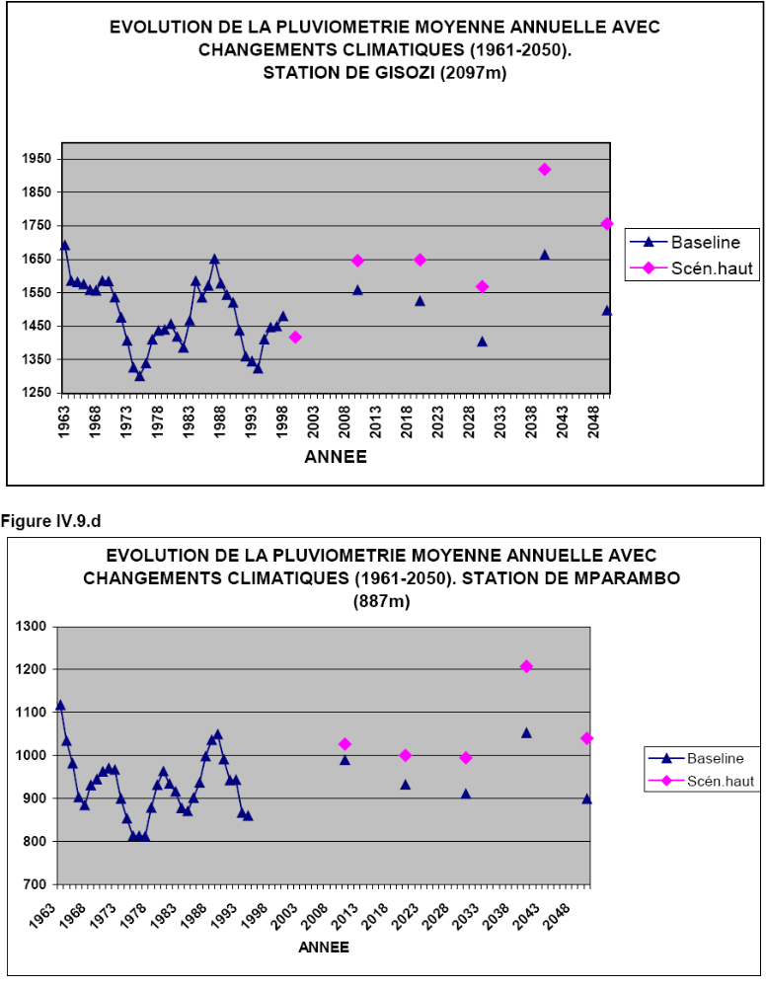
Figure 8 Time series of observed precipitation with projections of precipitation for the stations of Gisozi and Mparambo

Downscaled station projections
Results produced for this report use CSAG’s Climate Change Explorer tool – these are empirically downscaled scenarios produced through a statistical technique to produce station level projections of climate change from global climate models. They use the newer SRES A2 emissions scenario (see IPCC, 2000). Unfortunately Bujumbura is the only site available for Burundi.

For temperature changes, these are positive for both maximum and minimum temperatures and range from 1.7ºC to 3.0ºC across all the months and scenarios for average monthly maximum temperature. For maximum temperatures increases are higher in the months of June to September. Changes in average minimum temperature are higher but less variable throughout the year, ranging from increases of 1.8 ºC up to 3ºC.

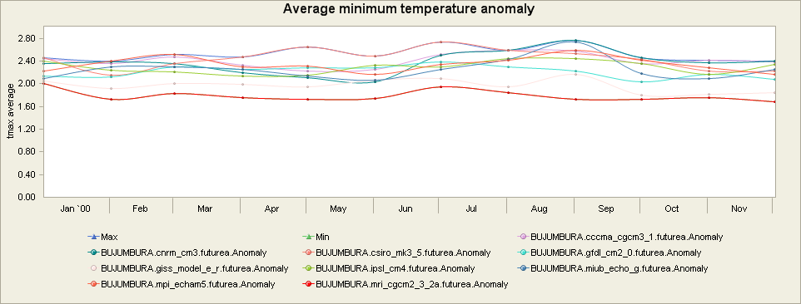
Figure 9 Average maximum temperature anomaly from the baseline for 2046-2065 timeslice

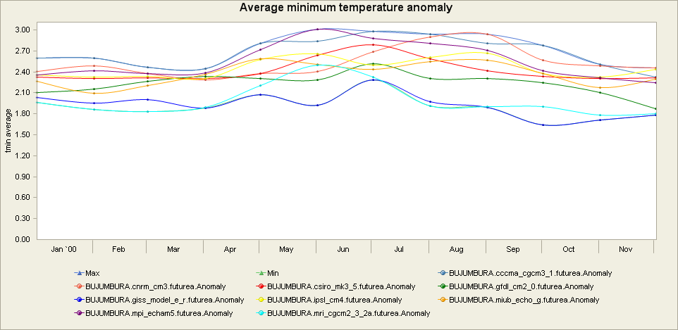
Figure 10 Average minimum temperature anomaly from the baseline for 2046-2065 timeslice

For precipitation there is a wide range in the projections of changes in monthly rainfall. January , May, July however all models are wetter than for baseline conditions – up to 18mm a month and for September and November all models except one are wetter. August has the most widespread across the models with 5 models being drying by up to 5mm a month. June and October also has models showing drying. To address the issue of extreme rainfall, the projected changes in number of rainy days above 90th percentile is plotted in Figure 12. This shows a mixture of increases and decreases in this variable for most months with December to march showing the most consistent increase in this indicator of extreme events variable.

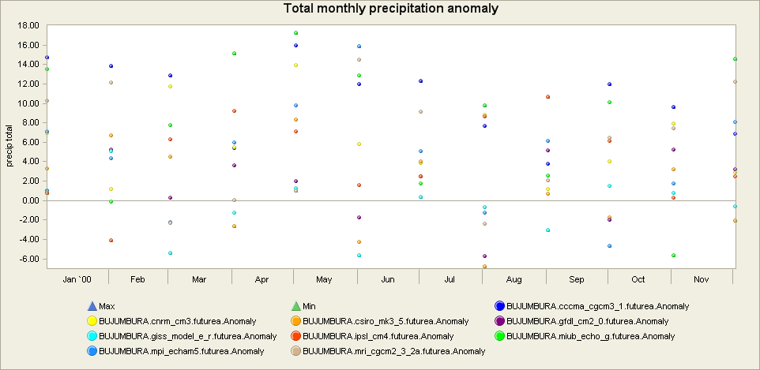
Figure 11 Monthly precipitation anomaly from the baseline for 2046-2065 timeslice

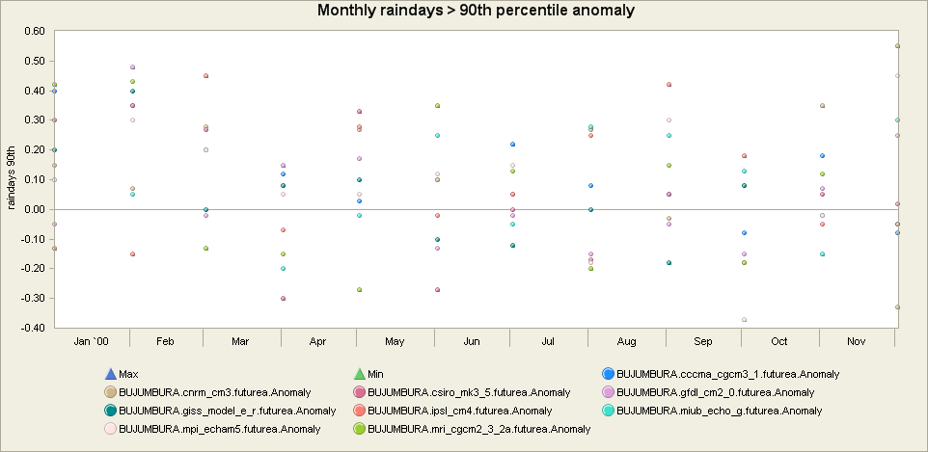
Figure 12 Monthly raindays> 90th percentile precipitation anomaly from the baseline for 2046-2065 timeslice

Summary
Meteorological data access issues limit the analysis of climate change in Burundi. The NAPA place emphasis on the witnessed climate variability and climate change based on historical information and traditional knowledge.

The SCENGEN scenario results for the sites of Gisozi and Mparambo show quite large increases in temperature by the middle of the century (up to 5ºC) which is higher than the highest of the CSAG GCM model outputs for Bujumbura. The precipitation projections also differ with higher increases of precipitation over a year by 2050 projected in the SCENGEN analysis being at least double that of the CSAG highest projection. There is some similarity in the possible of drying during the months of June to September in the SCENGEN analysis being reflected in some of the monthly modelled precipitation projections for Bujumbura.

Clearly more data and projections at more sites across a country with such variation in climate and altitude are required to give a more realistic picture of possible future conditions.

References
MINATTE (2001) : Première Communication Nationale au Titre de la Convention cadre des nations Unies sur les Changements Climatiques, Bujumbura.

Hewitson, B.C.; Crane, R.G., (2006). Consensus between GCM climate change projections with empirical downscaling. International Journal of Climatology, (2006).
IPCC special report: Emissions scenarios. Summary for Policymakers., 2000. Emissions Scenarios: A Special Report of IPCC Working Group III. Published for the Intergovernmental Panel on Climate Change. http://www.ipcc.ch/pdf/special-reports/spm/sres-en.pdf.

IGEBU, (2001) - Evolution climatique actuelle et développement des scénarios de changements climatiques à l’horizon 2050.

National Adaptation Plan of Action, Burundi, 2007. Republic Of Burundi, Ministry For Land Management, Tourism And Environment, Bujumbura.

MAGICC and SCENGEN (www.cgd.ucar.edu/cas/wigley/magic/) are coupled, user-friendly interactive software suites that allow users to investigate future climate change and its uncertainties at both the global-mean and regional levels. MAGICC carries through calculations at the global-mean level using the same upwelling-diffusion, energy-balance climate model that has been and is employed by IPCC. SCENGEN uses these results, together with spatially detailed results from the CMIP3/AR4 archive of GCMs, to produce spatially detailed information on future changes in temperature, precipitation and MSLP, changes in their variability, and a range of other statistics.
In running MAGICC/SCENGEN, the user can intervene in the design of the global or regional climate change scenario in the following ways:
- By selecting and/or specifying the greenhouse gas and sulfur dioxide emissions scenarios.
- By defining the values for a limited set of climate model parameters in MAGICC that are important in determining the effects of uncertainties in the carbon cycle, the magnitude of aerosol forcing, the overall sensitivity of the climate system to external forcing, and ocean mixing rate.
- By specifying the future time period for which results are displayed (out to 2400).
- By specifying the GCMs that are averaged to produce the climate change pattern information.
- By selecting an area or region for spatial averaging of climate change results.
This version of MAGICC/SCENGEN was developed primarily with funding from the U.S. Environmental Protection Agency, but it rests on developments carried out over the past 20 years that were funded by a number of organizations.

