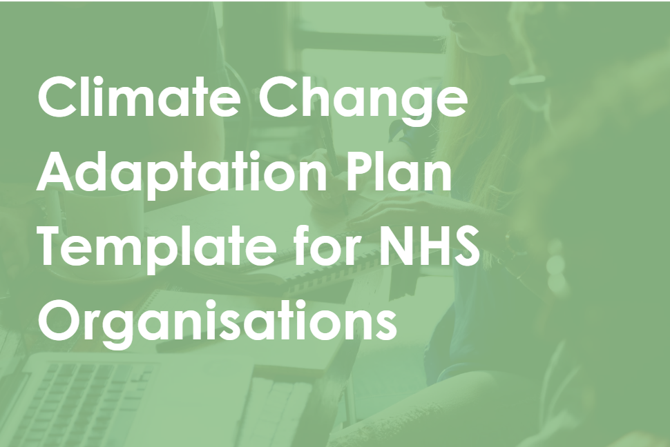







NHS Climate Change Adaptation Plan Template
This is a template that you can use as a working document to produce your own climate change risk assessment and adaptation plan. Rather than telling you how to assess your risks and adapt to climate change, this template acts as a starter when you are not sure where to begin, but includes reference to a range of resources that can help you assess your risks, build your ability, and help you plan to adapt to climate change. It also includes reference to how to include adaptation in your Green Plan, and further guidance on this and other reporting requirements, including TCFD-aligned disclosures and annual reporting, can be found here on the weadapt website, a platform for sharing free open-source materials for driving adaptation.
This template is free and open-source, produced by independent not-for-profit Sustainability West Midlands as part of a project in partnership with Sniffer, NHSE North West, NHSE North East and Yorkshire, and NHS Greater Manchester. To learn more about this project and to access the other resources produced, visit the weadapt website.
Consider sharing your adaptation plan, when completed, with other NHS organisations to share best practice and reduce duplication!
Contents
Introduction 1
Summary of very high priority actions 1
Relevant Maps and Data 2
Climate Projections 2
Climate Change Risk Assessment 2
Current Adaptation Progress 3
Adaptation Action Plan 4
Next Steps 5
Further information 5

Introduction
When describing the importance of adaptation for a resilient NHS that can achieve its objectives, be sure to answer the following suggestions within the Green Plan Guidance:
- “What specific improvements would most benefit your local communities, staff and the overall organisation?”
  - E.g., knowing the areas that are most at risk from climate change and adapting to these can support communities in being safer and healthier and the sites being more resilient.

- “Sustainable models of care”
  - A truly sustainable model of care should include considering opportunities for adaptation in the way care is delivered

Summary of very high priority actions
This space is an opportunity for you to provide an overview of the main actions you are currently focussed on carrying out to progress your adaptation work. These come from the later section ‘Adaptation Action Plan’. This summary could also be included in your Green Plan.

Relevant Maps and Data
If you have maps that are relevant to your risk assessment and adaptation plan, you can include these here. For example:
- Site maps
- Map of the integrated care system that you sit within (you and other Trusts, other primary care organisations, ICB, LA)
- Maps of flood risk, water stress, and temperature projects
- Vulnerability maps showing areas of deprivation or other health-related demographics.
You should also consider including some of these in your Green Plan, as the Green Plan guidance suggests that you “include pertinent demographic and socioeconomic details of the local populations served.”

Climate Projections
This should include projections of the change in climate expected in the locations of your sites and communities. Some of the maps you included in the previous section will demonstrate this, but a written summary of expected changes in:
- Rainfall
- Flooding
- Temperatures (min, max, winter, summer, annual)
- Number and intensity of extreme events (heat, rainfall, storms)
- Sea level rise (if applicable)
Where you do not have these for your area, you can use regional or national summaries. See the UK Climate Change Risk Assessment (UKCCRA) for national summaries on projected climate change. For project climate change impacts (which you will include in your risk assessment section), there are UKCCRA sector specific briefings including one for health and social care. For more local project impacts, you can use the Local Climate Adaptation Tool (LCAT). Check whether your local or regional authority may have produced climate change risk assessments.
See Adapt to Survive section 3.1 for further advice on how to find climate projections.
A summary of this information could be included in your Green Plan.
You could write a couple sentences here on how this relates to health generally, but impacts will be covered in detail later.

Climate Change Risk Assessment
- The likelihood of different types of severe weather events and their associated hazards occurring on our sites and in the communities we cover.

Historic Impact Assessment
- Extreme events that have occurred in recent years and the impacts they had on your sites or communities
Date | Weather event | Hazards | Location | Weather information | Impacts | Likelihood | Impact | Overall (lxi)
Whenever a severe weather incident impacts your sites or stakeholders, logging some details here including what happened, how severe it was and its impacts will allow a more accurate prediction of the impacts of the items in your risk assessment, as well as help build a case for support by showing the consequences of climate change for your site and operations. This may not necessarily show you how likely the events are in future but will give you an indication of how your Trusts and local area deals with impacts that occur during a heatwave, for example.
See Adapt to Survive 3.1 for ways to find the data for a past impact assessment and what this can be useful for.

Future Risk Assessment
You should then produce a list of impacts that could occur to your sites as a result of these events.
See Adapt to Survive 3.1 for sources you can use to measure immediate, medium and long-term risks.
See Adapt to Survive Worksheet Tab 3 for the types of impacts that could occur on your sites split into types of impact (service disruption vs direct health impact) and categories to help you whittle down what is relevant to you. Tabs 3a and 3b along with the Adapt to Survive Guide help you determine your own potential impacts.
Hazard | Likelihood | Potential Impact | Severity | Priority Level (Likelihood x Severity)
You can add other columns that can be found in Adapt to Survive such as: previous examples of impact, cost associated, service area…

Current Adaptation Progress

Previous objectives and actions
Looking at previous adaptation plans, objectives, or commitments made, measure and evaluate your progress on these.
If you already have governance for adaptation in place, then include details of this here. The Green Plan guidance also requests this information in general: “operation of sustainability committees and working groups; development of online sustainability training and pledge platforms for staff; and investment in specific staff to support sustainability goals” – so be sure to include your adaptation governance within this section of your Green Plan.
Objective/Action/Commitment | Deadline | Progress | Evidence | Comments/Next Steps
 |  |  |  | Can highlight barriers so far, explain why something wasn’t achieved and what will be done to achieve/alter it

Use the Plan, Do, Study, Act process for monitoring and evaluation. See Climate Adaptation Framework for NHS organisations for more on monitoring and evaluation.

Case studies
Provide some examples of adaptation that you have carried out so far. You can also include here some evidence of adaptation planning you have been carrying out or adaptation networks you are a part of. One or two key case studies could be included in your Green Plan.

Adaptation Planning Maturity
You could include how mature you are within the Climate Adaptation Framework for NHS organisations in the four different capabilities:
- Understanding the Challenge
- Organisation Culture and Resources
- Planning and Implementation
- Working Together

Adaptation Action Plan
These could be grouped into categories such as:
- Planning, Policies and Governance
- Utilities, Equipment & maintenance
- Operations
- Estates (upgrades, retrofit, new buildings)
- Communications & Behaviour Change
- Data collection and monitoring
- Training
- Procurement and Supply Chain
Or the teams responsible such as:
- Estates
- Sustainability
- EPRR
- Facilities
- Maintenance
- Procurement
- Finance
- Communication
Adaptation Technique | Priority Level | Potential Partners | Action(s) | Team/Individual Responsible | Resource required | Deadlines
Could include other columns including: category; impacts Addressed; current barriers; requirements met; useful resources.

Next Steps
If you wish, you can take the opportunity here to share any immediate plans you have to start implementing any of your actions, or to prepare yourself to be able to. For example, if you are currently exploring financing options, are recruiting for a new post, or working on your governance structure before implementing actions. This section is not essential, but rather is a final opportunity for you to add anything you haven’t yet included in this plan but would like to.

Further information

Methodology
It is good practice to include how you have come to your projections and impact evaluation and whether these have been updated since your last report. If you use Adapt to Survive, you can reference the methodology in this.
You should include your reasoning for the actions you have chosen. If you set out an appraisal process (formal or informal), this can be a good way to justify your planning and to help others within and outside your organisation to do their own appraisal. See the Climate Adaptation Framework for NHS organisations for more advice on this. You could consider including details of your appraisal process in the governance and/or adaptation sections of your Green Plan.

Definitions
Risk
Hazard
Vulnerability
Flash Flooding
Fluvial Flooding
… | …

See Adapt to Survive and the Adaptation Capability Framework for NHS organisations in England for definitions and climate change context.

Acronyms
NHS | National Health Service
EPRR | Emergency Planning, Preparedness and Response
… | …

Related Documents and Themes
This is a space where you can reference any other internal or external reports that are relevant to your Climate Change Risk Assessment and Adaptation Planning. Examples could include:
You can also make some comments on how adaptation relates to other themes within the NHS, for example with a table showing different themes and different related policies such as the one below. This could be included in your Green Plan, using all the green plan categories
 | Net Zero | Climate Adaptation | Health Inequalities | Air Pollution | Emergency Planning
Adverse Weather Health Plan |  | 
Community Engagement plan

Local Resilience Forum plans or reports
Net Zero Plans
This Climate Adaptation Plan
Relevant Emergency, Preparedness, Resilience and Response documents
Regional adaptation plans (Local Authorities, Regional Authorities, Integrated Care System…)

Remember: you can visit the weadapt website, a platform for sharing free open-source resources to drive adaptation, for more information relating to this template and other adaptation support for the NHS, all under the tag #NHSadapts.

